This revision will deepen your understanding of the circulatory, digestive, respiratory, reproductive, and excretory systems, along with related general concepts. It is scaffolded to guide you through the revision of each system.

**Step 1: Background Research**

Start by researching and making notes on the terms provided for each system. Use Jacplus, educational websites, and reliable sources to gather information on the following:

**Circulatory System:**

* Arteries

Pump blood away from the heart.

* Veins

Pump blood to the heart.

* Platelets

A small fragment involved in the clotting property of the blood

* Aorta

The main artery carrying oxygenated blood to all parts of the body.

* Left atrium

Receives oxygenated blood from the lungs.

* Left ventricle

Pumps oxygenated blood to the body.

* Pulmonary artery

Carries deoxygenated blood to the lungs.

* Pulmonary vein

Carries oxygenated blood from the lungs.

* Right ventricle

Pumps deoxygenated blood to the lungs.

* Superior vena cava

Carries deoxygenated blood from the body to the heart.

* Right atrium

Segment of the heart that receives deoxygenated blood.

* Oxygenated blood travel

Starting from the body, deoxygenated blood goes through the Vena Cava, Through the right atrium and into the right ventricle, to the pulmonary artery. The lungs receive deoxygenated blood, and converts it to oxygenated blood. The oxygenated blood then goes through the pulmonary vein, to the left atrium and left ventricle, through the Aorta, and eventually oxygenated blood makes it back to the body.

* Diagram of the heart and its structures

* Components of blood and their functions

|  |  |  |
| --- | --- | --- |
| **Red Blood Cells** | **Flows nutrients and trades oxygen for carbon dioxide** | Blood Cell Drawing at PaintingValley.com | Explore collection of Blood ... |
| **White Blood Cells** | **Protects the body from bad bacteria** | White Blood Cells on emaze |
| **Plasma** | **Suspends blood cells and platelets** | Diagram with plasma membrane 359340 Vector Art at Vecteezy |
| **Platelets** | **Stops bleeding by forming a scab.** |  |

**Digestive System:**

* Bolus

Food that has been/is in the process of becoming chewed up.

* Peristalsis

A series of muscle contractions that help push food down from a canal. This is used to push food from your oesophagus to your stomach.

* Mechanical and chemical digestion comparison
  + Mechanical digestion is the process of physically breaking down food, like with your teeth. It does not change anything chemically about the food.
  + Chemical digestion is the process of using enzymes to break down certain molecules of the food. It *does* change things chemically about the food.
* Oesophagus

A long canal that carries food to the stomach using peristalsis or muscle contractions.

* Liver

Makes bile which breaks down fat, controls blood sugar, destroys poisons, and stores Vitamin A, D, and Iron.

* Enzymes and their importance in digestion

Enzymes are important because they allow for proper breakdown of foods, allowing the body to harness the nutrients that the food contains. Enzymes are biological catalysts that speed up reactions in important processes.

* Diagram of the digestive system

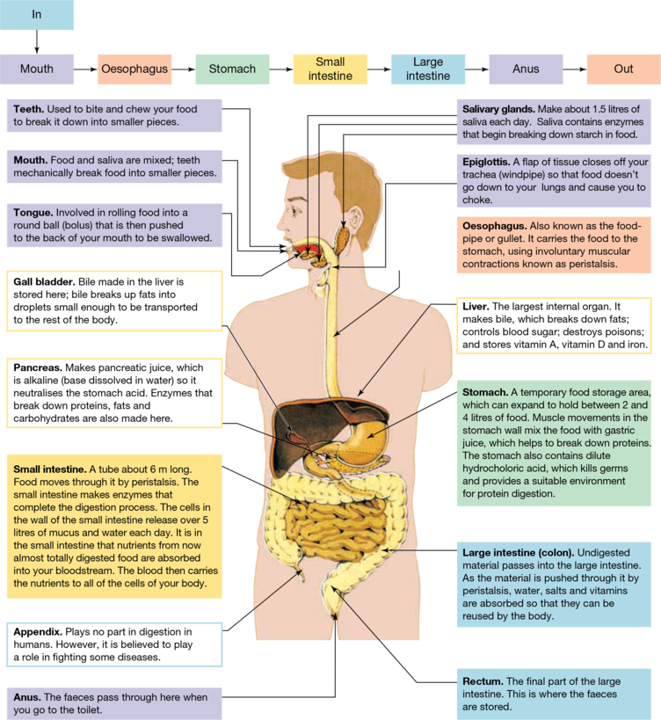

**Respiratory System:**

* Bronchi

Long tubes that passage air from the trachea to the lungs.

* Trachea

Tube that links the nose and mouth with the lungs.

* Diaphragm

A large, dome-shaped muscle that contracts rhythmically and continually. Upon inhalation, the diaphragm contracts and flattens and the chest cavity enlarges. This contraction pulls air into the lungs.

* Role of the respiratory system

The main role of the respiratory system is to allow you to breathe by performing gas exchanges. That is, it inhales oxygen, uses oxygen to perform cellular respiration, and then exhales carbon dioxide.

* Asthma

A lung disorder that causes the airways (bronchi) to become narrowed, causing less air to travel through, causing wheezing or coughs and shortness of breath.

* Diagram of the human respiratory system and function of each part

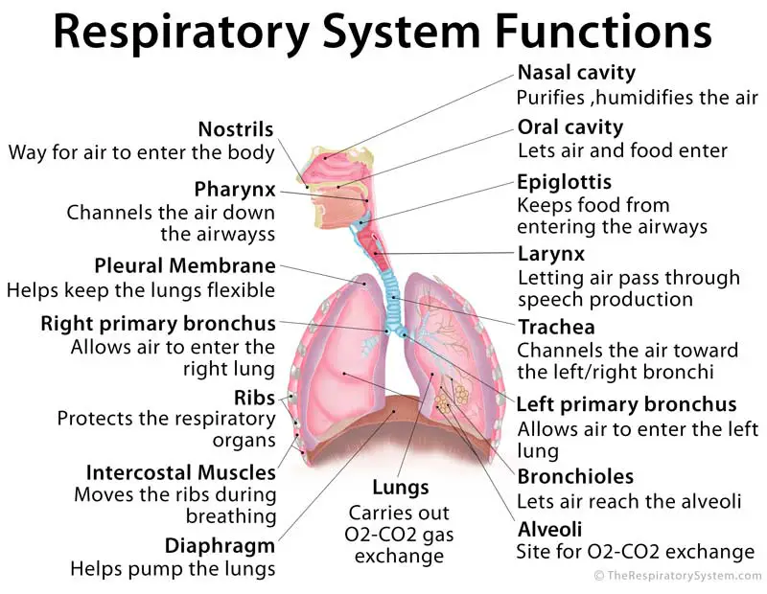

**Reproductive System:**

* Fallopian tube

Tubes on each side of the uterus that transports eggs from the ovaries to the uterus.

* Uterus

A hollow muscular organ that allows eggs to be implanted and fertilized on the lining of the uterus.

* Seminal vesicle

A gland in males that produces the fluid that is mixed with sperm to protect it from high acid levels.

* Vas deferens

A long muscular tube that transports sperm to the ejaculatory duct.

* Structures of the female reproductive system diagram

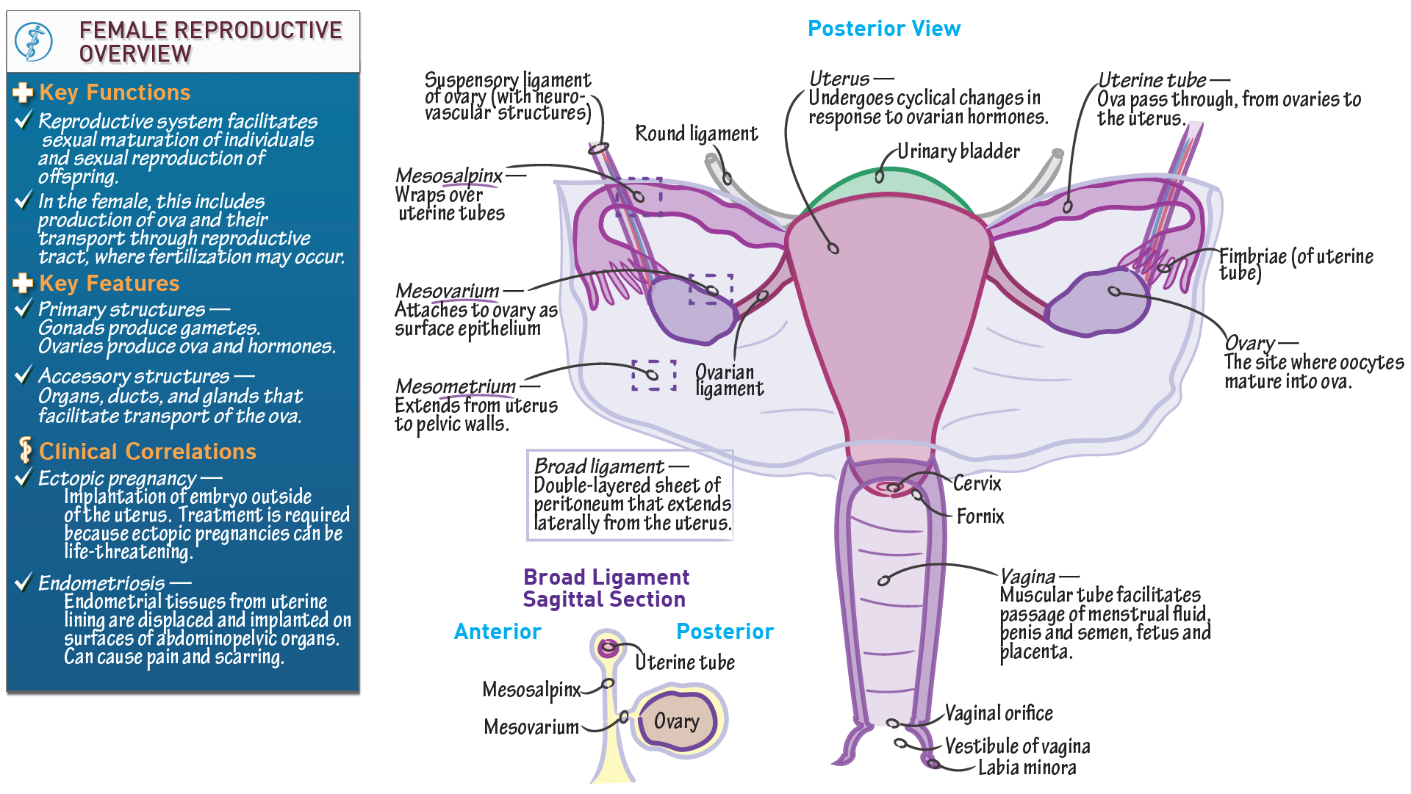

**Excretory System:**

* Kidney and its functions

Small organs near the abdomen that expel waste and excess water from blood cells, and help keep chemicals like sodium, potassium, and calcium balanced in the body. The kidney also makes hormones that control blood pressure.

**General Concepts:**

* Tissue

A group of similar structured cells that all perform the same purpose together.

* Plasma

The liquid portion of blood that suspends blood cells and platelets in itself. Plasma is 92% water.

* Serum

A fluid and solute compound that contains all proteins unrelated with clotting blood, so it’s a blood cell that doesn’t have any clotting factors.

* Water

A fundamental solvent in the biochemical processes of the human body.

**Step 2: Creating Body System Diagrams**

Choose one system at a time and create a labelled diagram for each. Ignore the excretory system.

**Step 3: Compare and contrast questions**

Complete the following questions.

**Circulatory System:**

1. **Arteries:** How do arteries differ from veins in terms of their structure and function within the circulatory system?

Arteries carry blood away from the heart rather than to the heart like a vein would.

1. **Platelets:** What role do platelets play in the process of blood clotting, and why is this process essential for the body?

Platelets stick together like glue to form the scab. Other blood cells join in to form a clot. This is essential to the body as it can stop a major loss of blood, as too much blood loss can lead to severe injury or even death.

1. **Pulmonary Artery:** Describe the path taken by deoxygenated blood as it travels from the heart to the lungs through the pulmonary artery. Why is this journey significant?

The deoxygenated blood travels through the vena cava, the right atrium and ventricle, the pulmonary artery, and then to the lungs, where it becomes oxygenated blood. The pulmonary artery carries the deoxygenated blood to the lungs, where it receives oxygen and releases some carbon dioxide.

1. **Superior Vena Cava:** Explain the role of the superior vena cava in returning blood to the heart. How does it contribute to efficient circulation?

The vena cava transports de-oxygenated blood to the right side to the heart, in which the ventricle pumps the blood to the lungs.

1. **Oxygenated Blood Travel:** Trace the journey of oxygenated blood from the left ventricle of the heart to a body tissue and back to the heart, detailing the vessels it passes through.

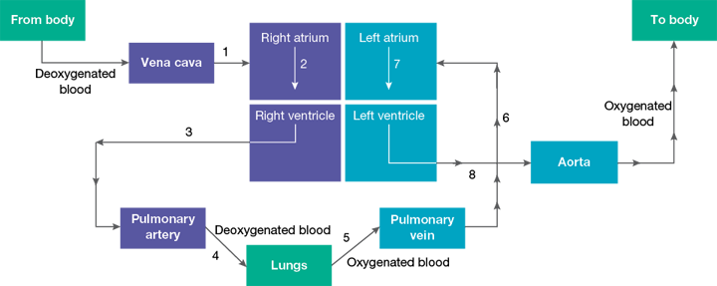

Oxygenated blood originates from the lungs, where deoxygenated blood receives oxygen. The pulmonary vein brings the blood from the lungs to the heart, where it enters from the left atrium and leaves from the left ventricle. The oxygenated blood then goes to he aorta, where it travels to the rest of the body.

**Digestive System:**

6. **Peristalsis:** How does peristalsis aid in the movement of food through the digestive system, and which organs are involved in this process?

Peristalsis aid in the movement of food by pushing the food down via a set of contractions.

The oesophagus is important in this process as it contains the muscles that perform the contracting.

1. **Liver:** Discuss the liver's role in digestion and detoxification. How does it contribute to the breakdown of nutrients and the removal of waste products?
2. Makes bile which breaks down fat, controls blood sugar, destroys poisons, and stores Vitamin A, D, and Iron. All of this is down by making and using bile, made from toxics or other resources otherwise useless to the liver.
3. **Enzymes in Digestion:** Explain how enzymes function in the digestive system. Provide an example of an enzyme, its source, and the specific nutrient it helps to break down.

Transferases are enzymes that catalyse the transfer of various chemical groups (other than hydrogen) from one compound to another. They can break down amino acids to a-keto acids

**Respiratory System:**

9. **Bronchi:** What is the function of bronchi in the respiratory system, and how do they contribute to the exchange of gases in the lungs?

1. **Diaphragm:** Describe how the diaphragm assists in the process of breathing. What happens when the diaphragm contracts and relaxes?
2. **Asthma:** How does asthma affect the respiratory system and airways? Explain the role of inflammation and narrowing in causing asthma symptoms.

**Reproductive System:**

12. **Uterus:** Explore the function of the uterus in the female reproductive system. How does it support fetal development during pregnancy?

1. **Seminal Vesicle:** What is the purpose of the seminal vesicles in the male reproductive system? How do they contribute to the composition of semen?
2. **Fallopian Tube:** Detail the role of fallopian tubes in the process of fertilization. How do they transport the egg and facilitate its meeting with sperm?

**Excretory System:**

1. **Kidney and its Functions:** Explain the main functions of the kidneys in the excretory system. How do they regulate waste removal, fluid balance, and electrolyte levels in the body?

**General Concepts:**

16. **Tissue:** Define the term "tissue" and provide examples of different types of tissues in the human body. How does the arrangement of cells contribute to the function of each tissue type?

1. **Plasma and Serum:** Differentiate between plasma and serum in blood composition. How do these components play a role in maintaining bodily functions?
2. **Water:** Discuss the importance of water in various body systems. How does water contribute to processes such as digestion, circulation, and temperature regulation?

As you engage in this activity, remember that the goal is not just to memorize terms, but to truly understand how different structures contribute to the complex functioning of the human body.

Top of Form